Chapter 2.3.3 - storage-services-from-kubernetes-applications

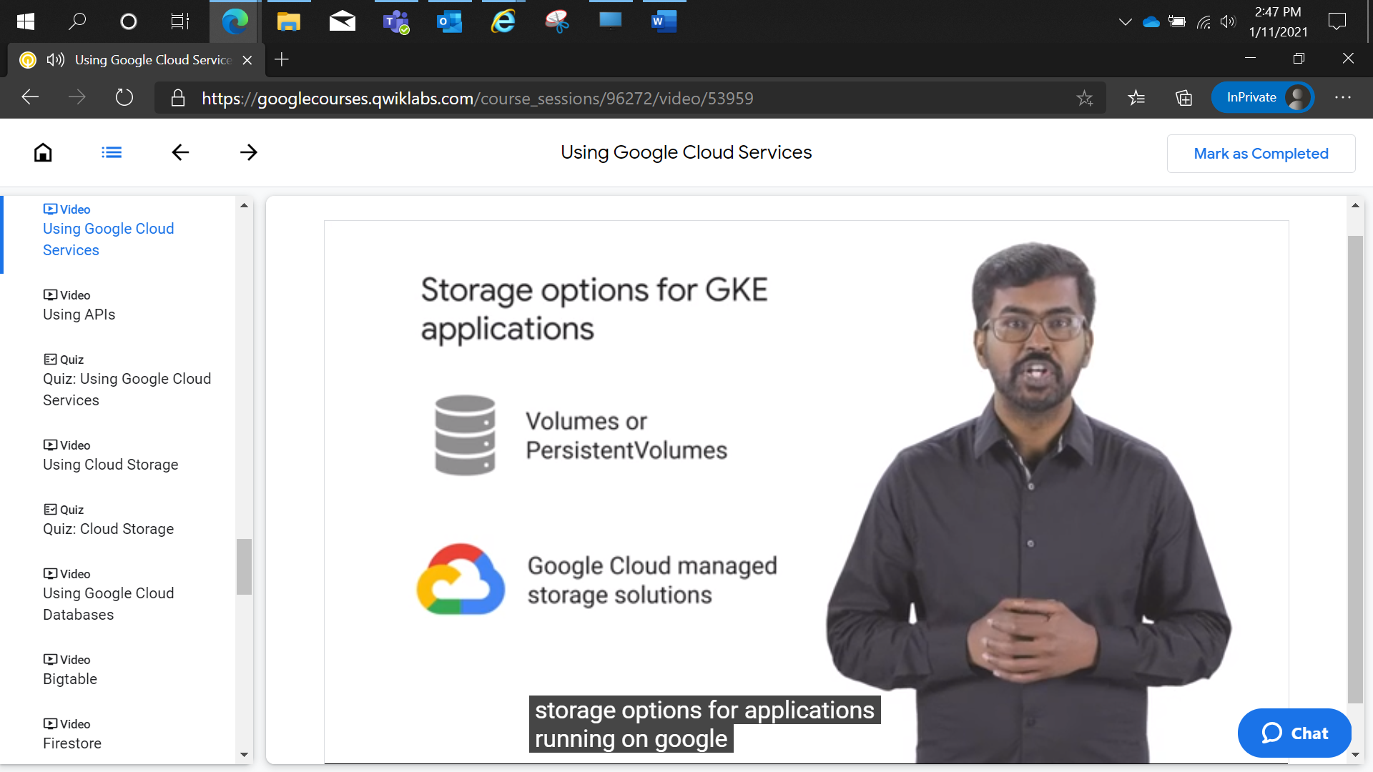

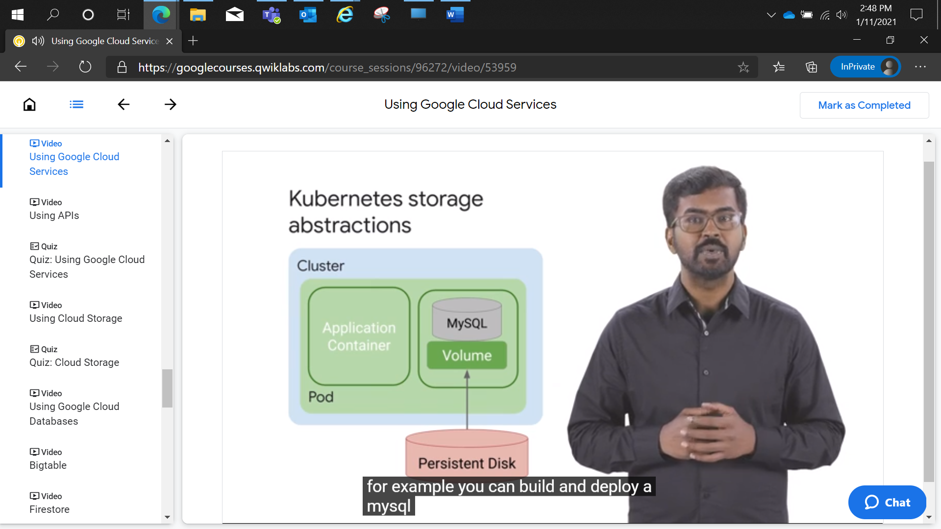

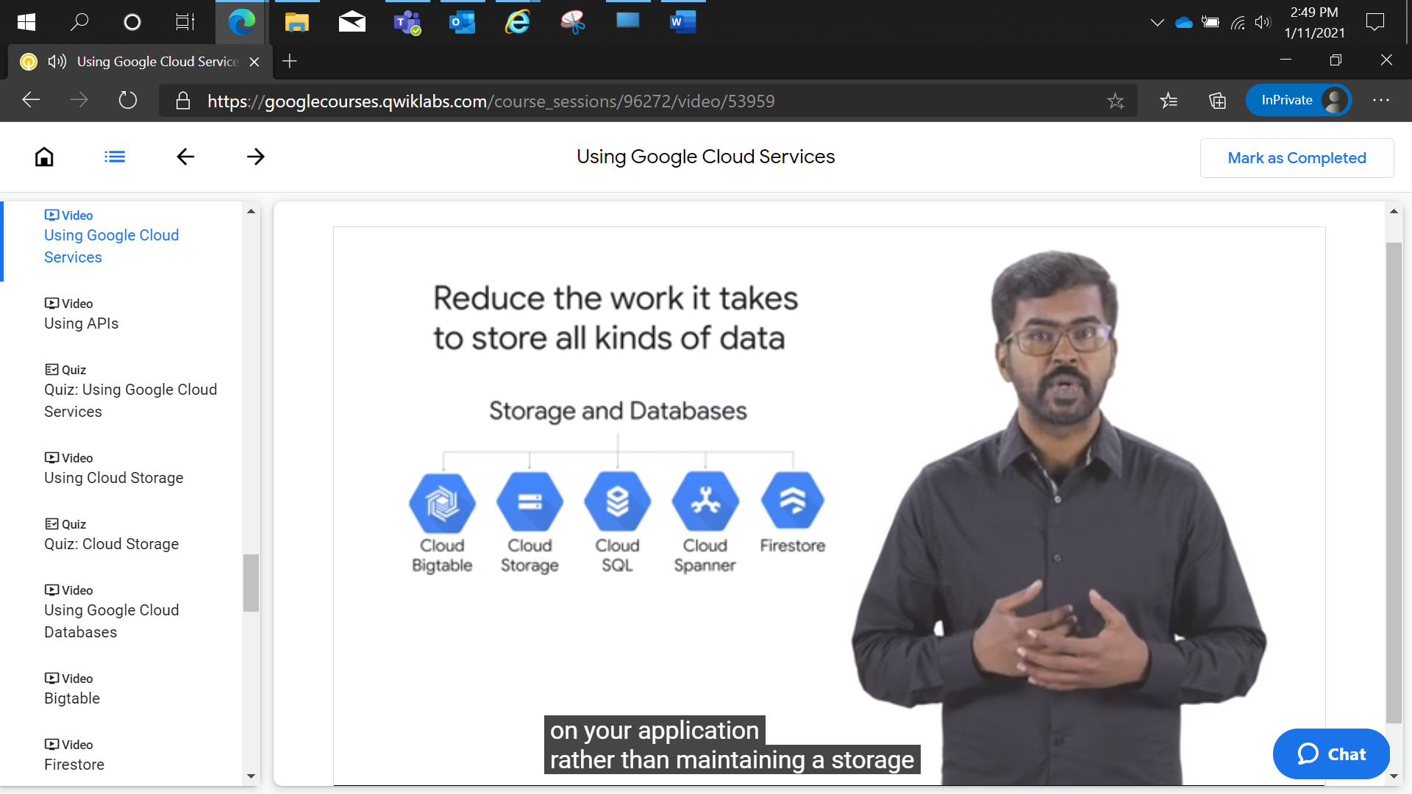

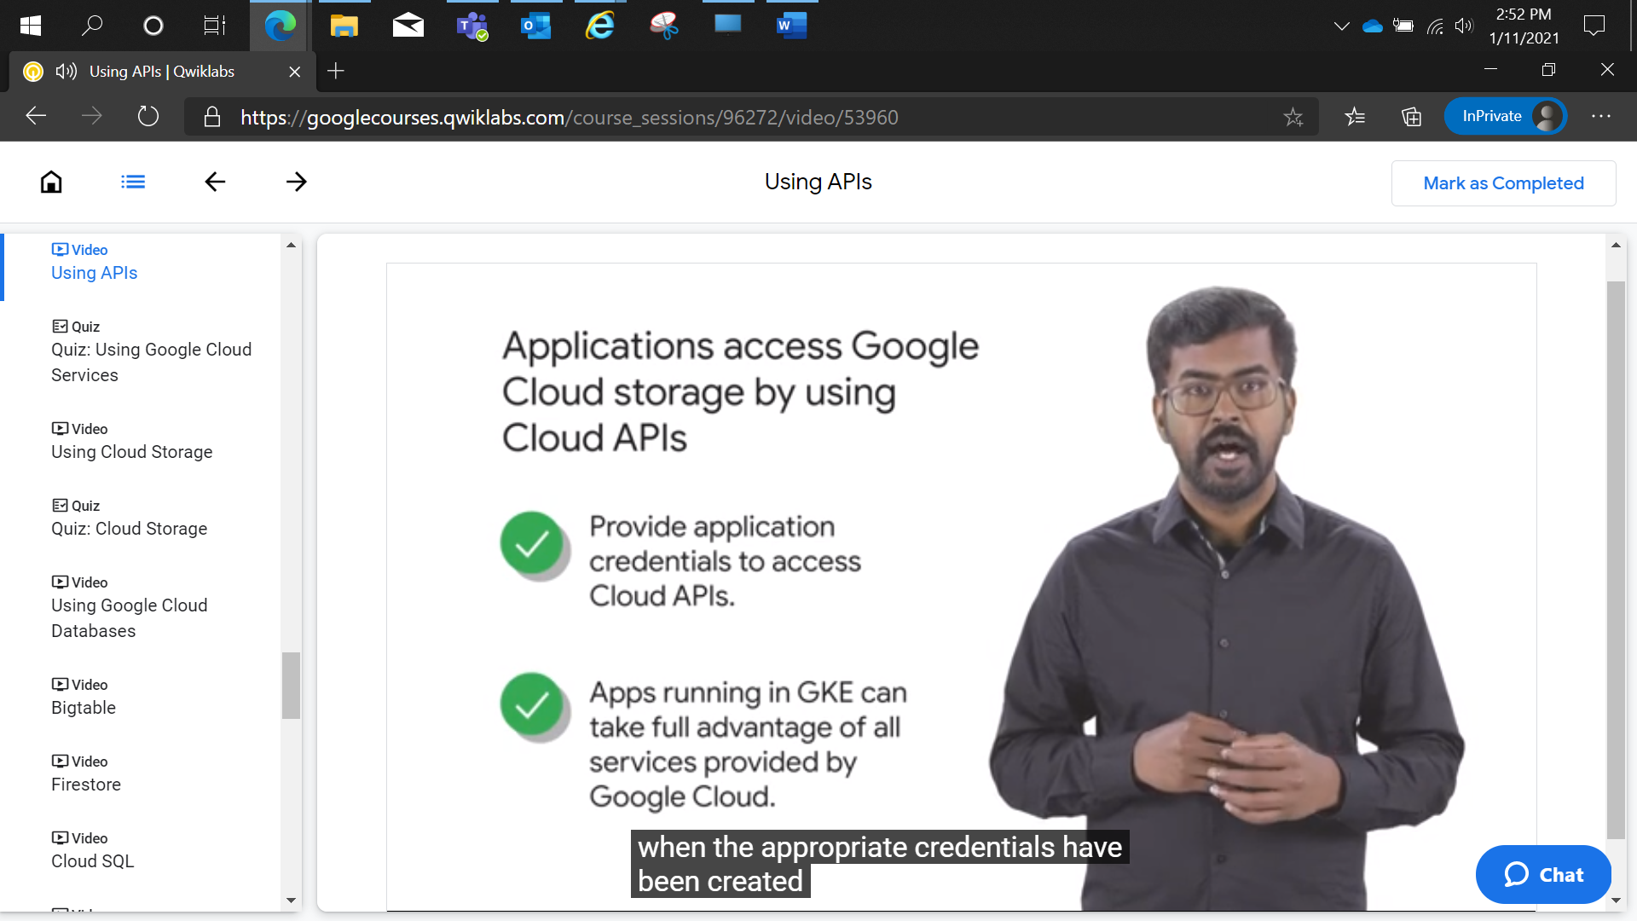

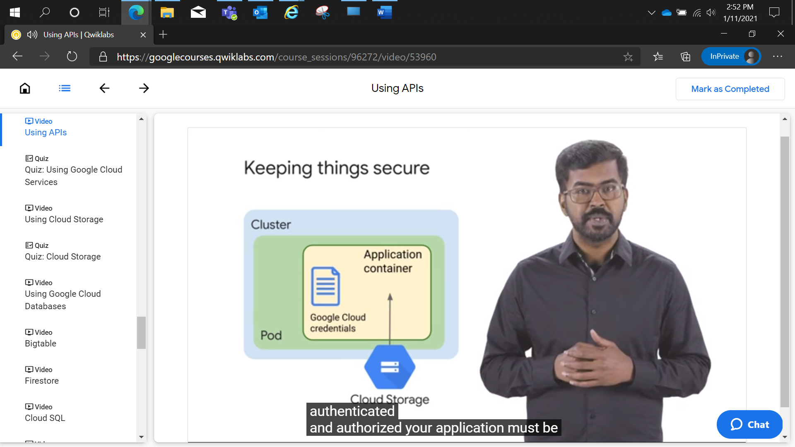

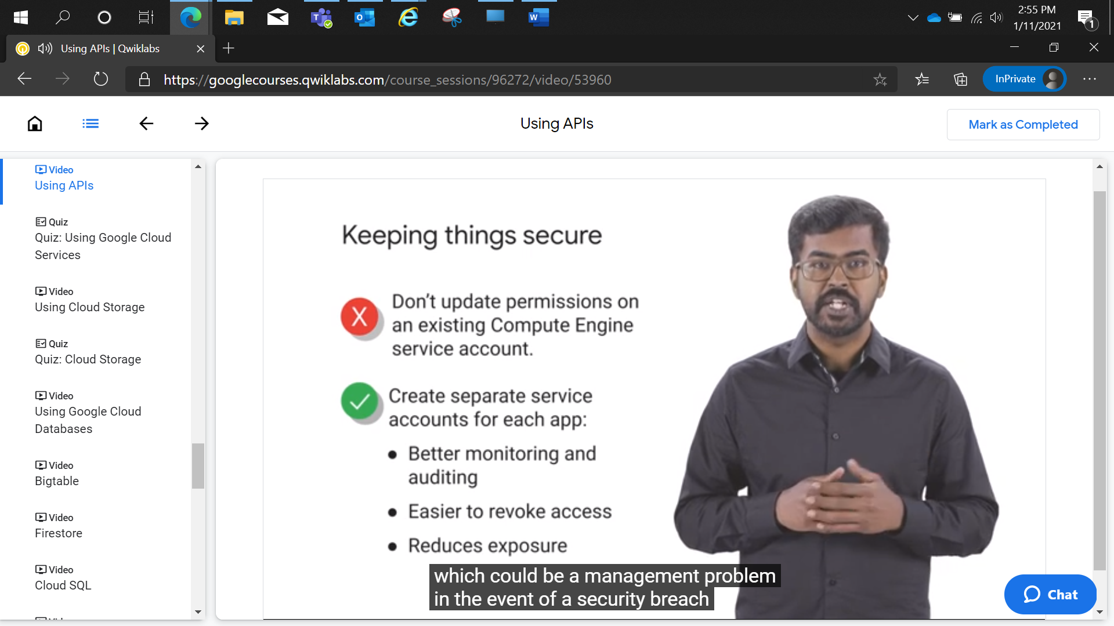

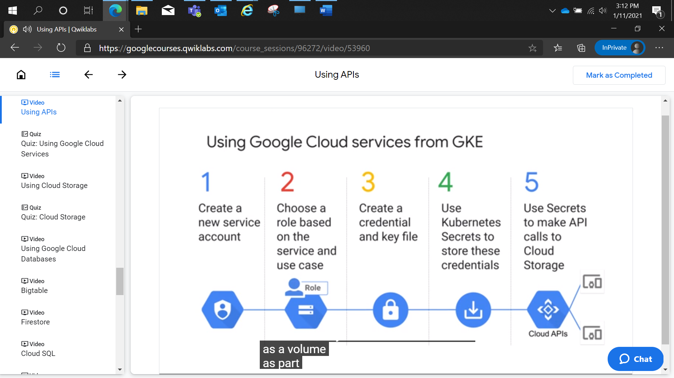

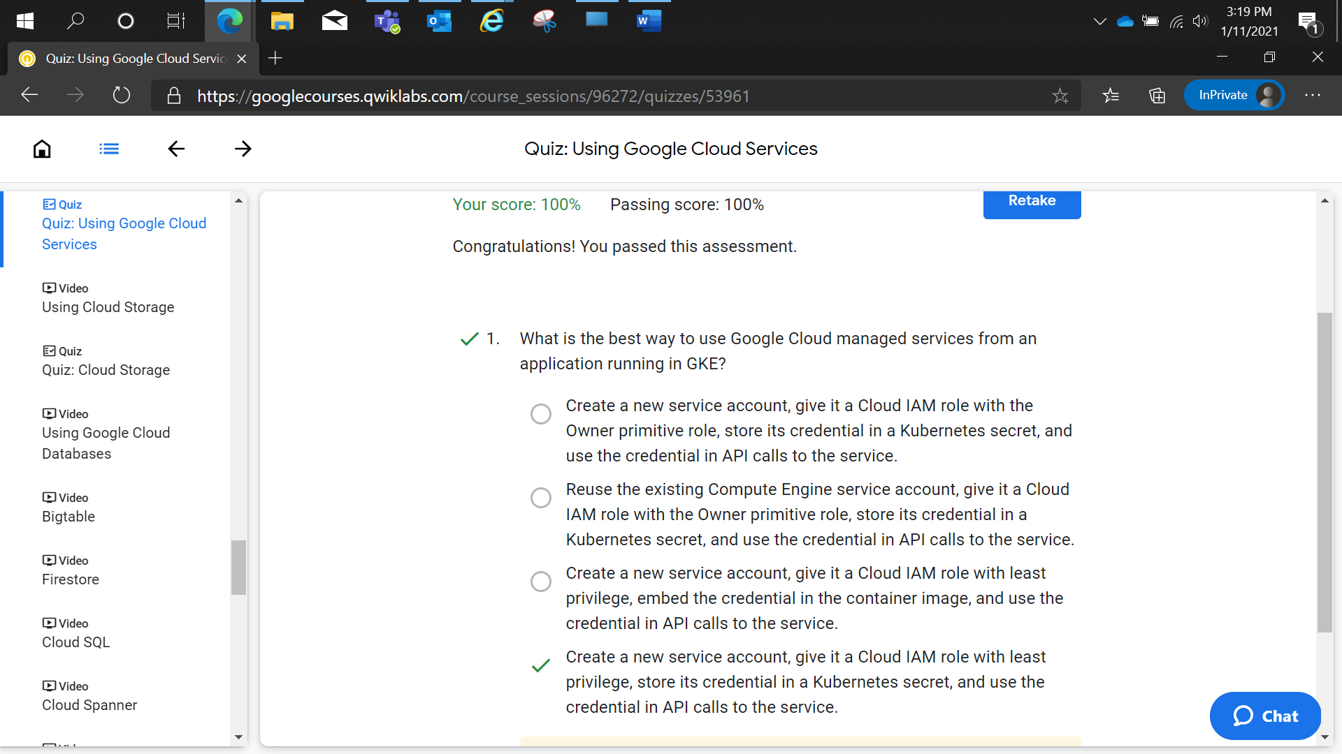

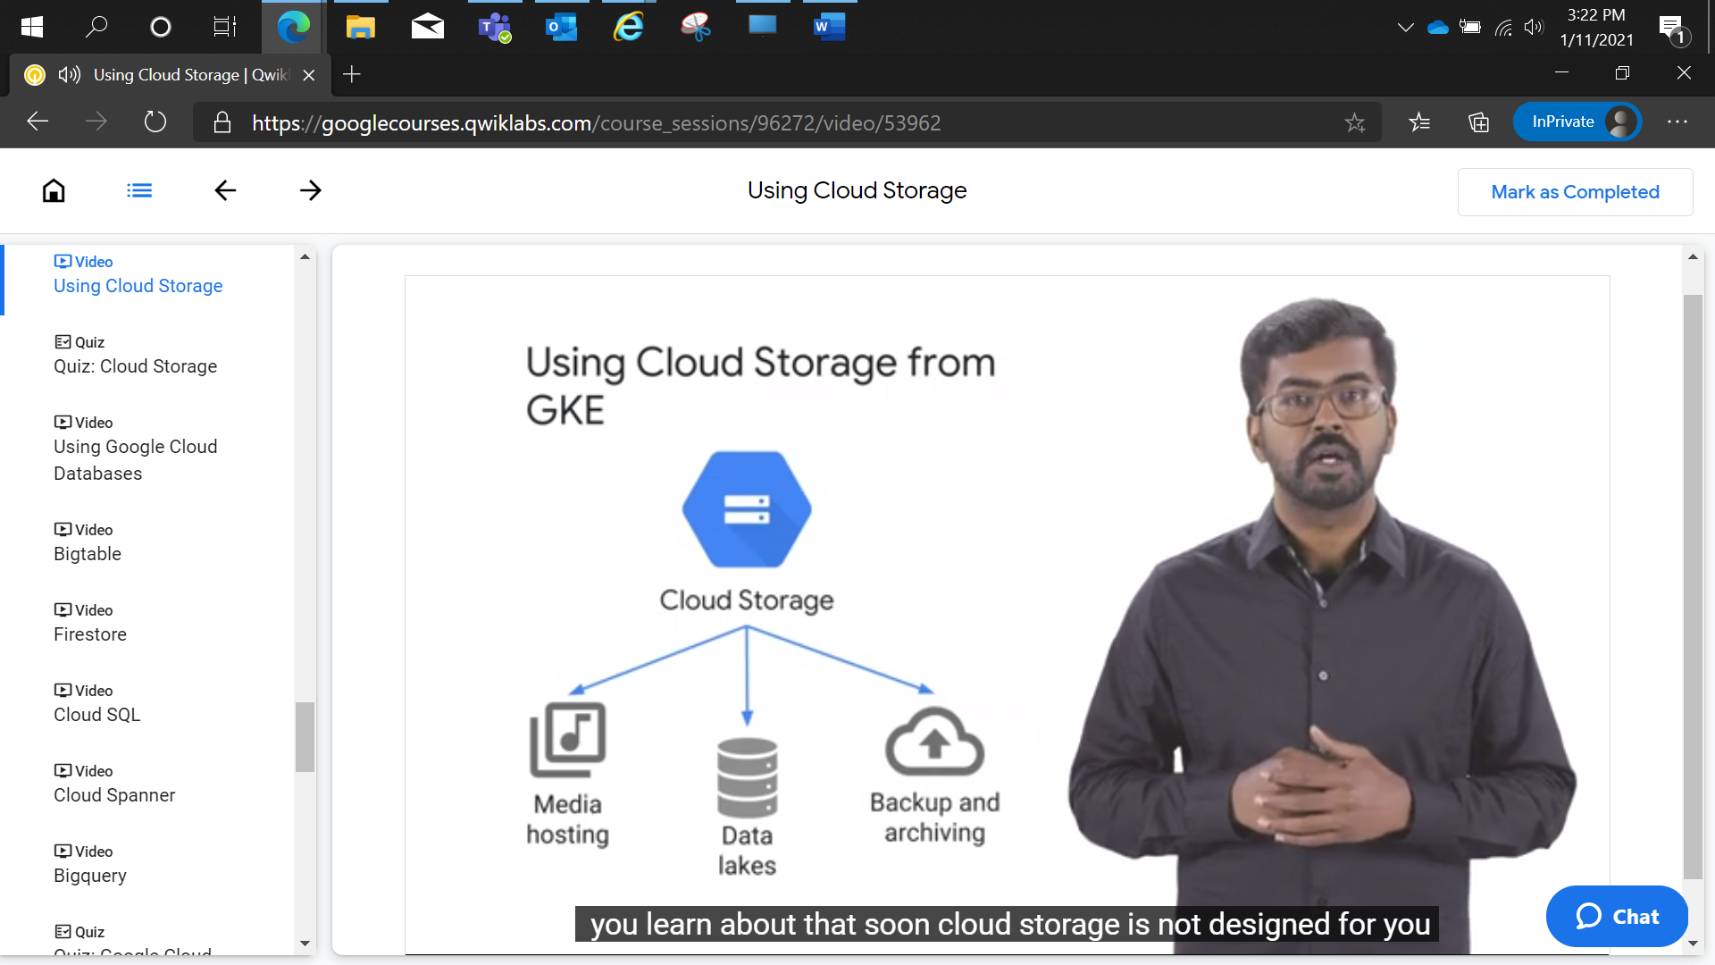

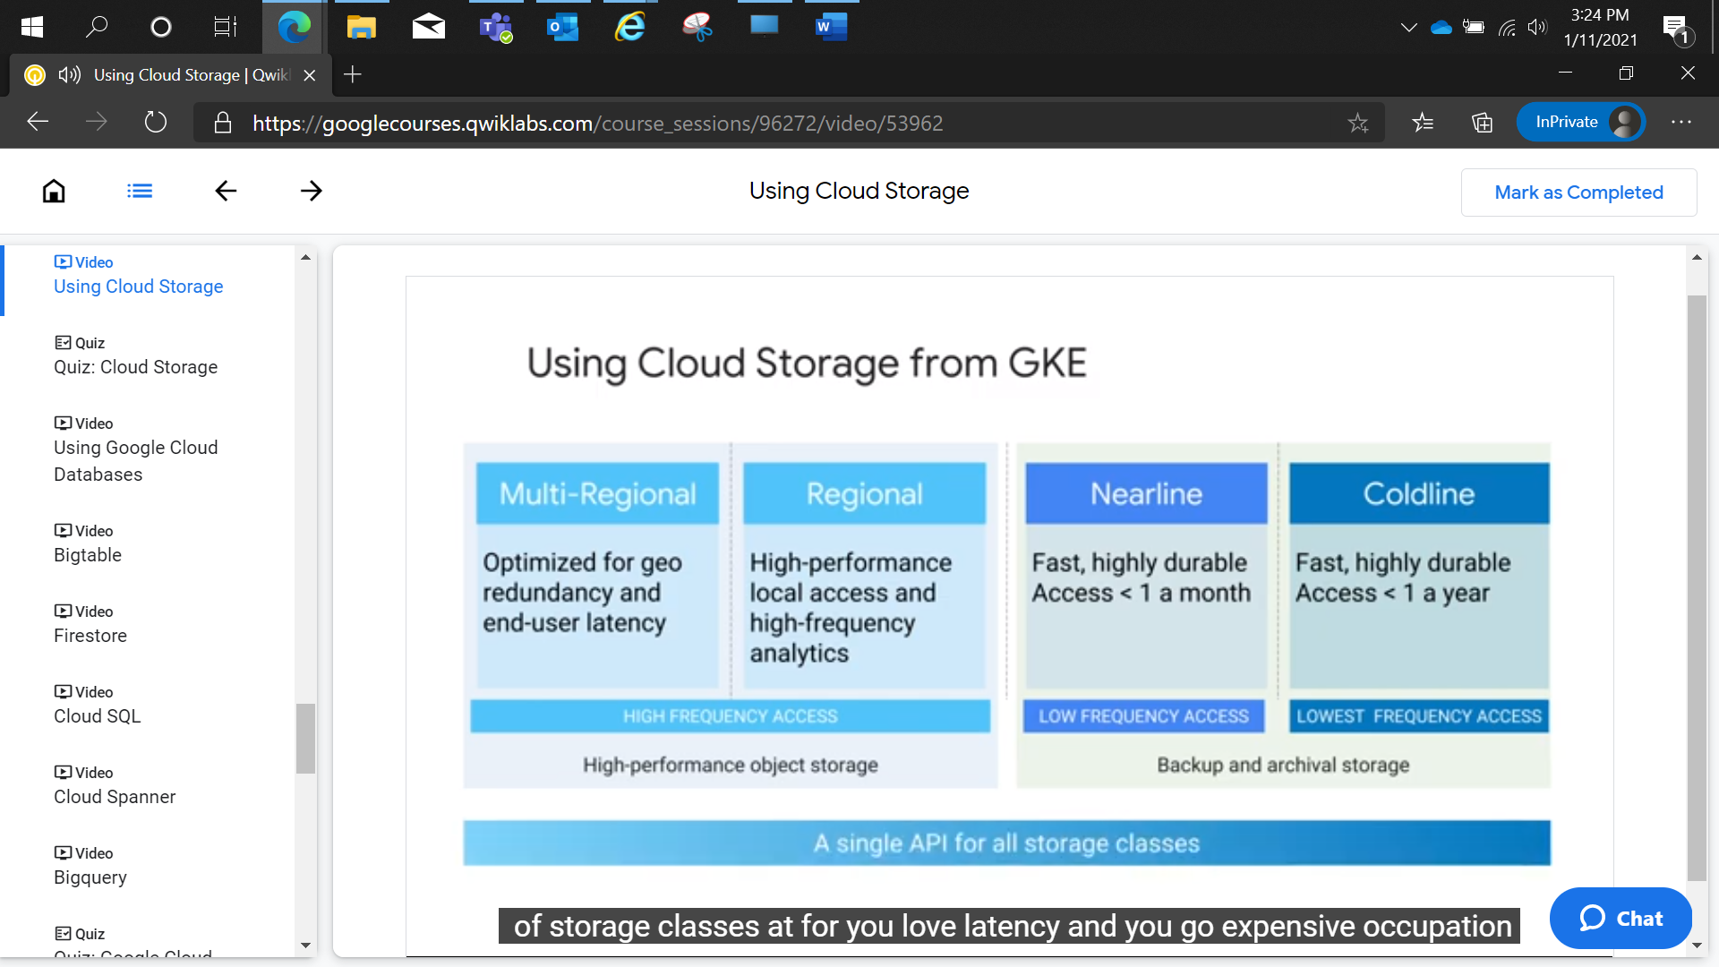

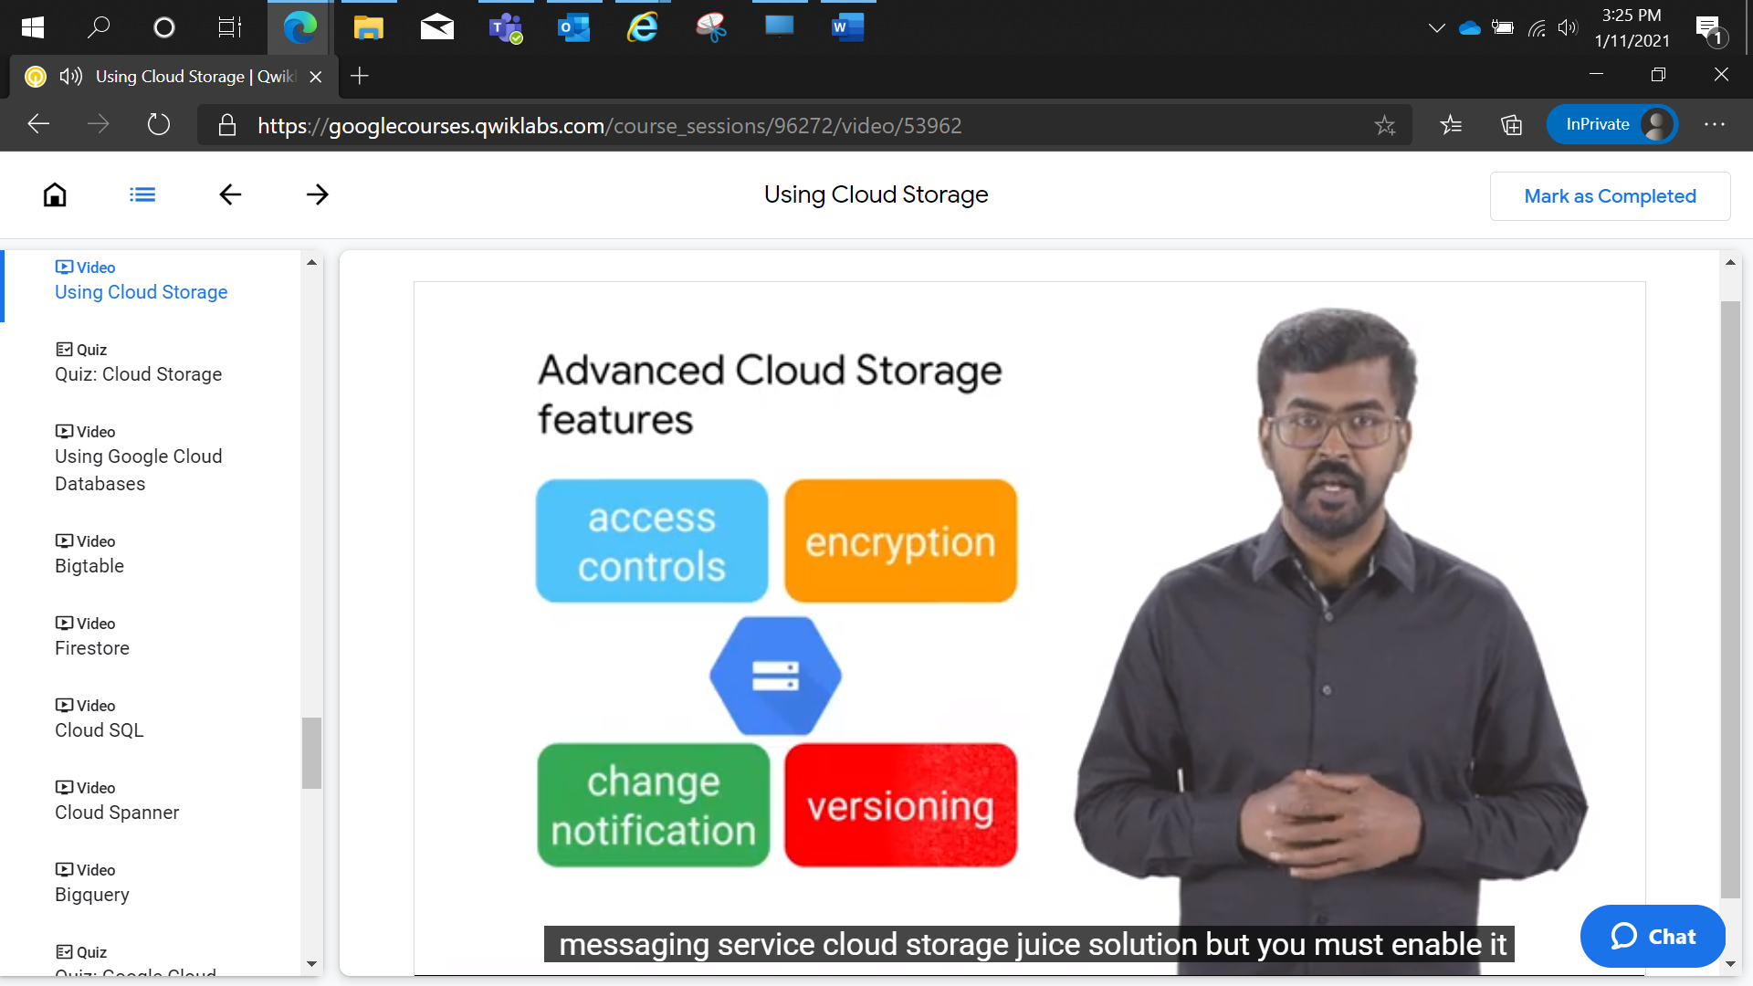

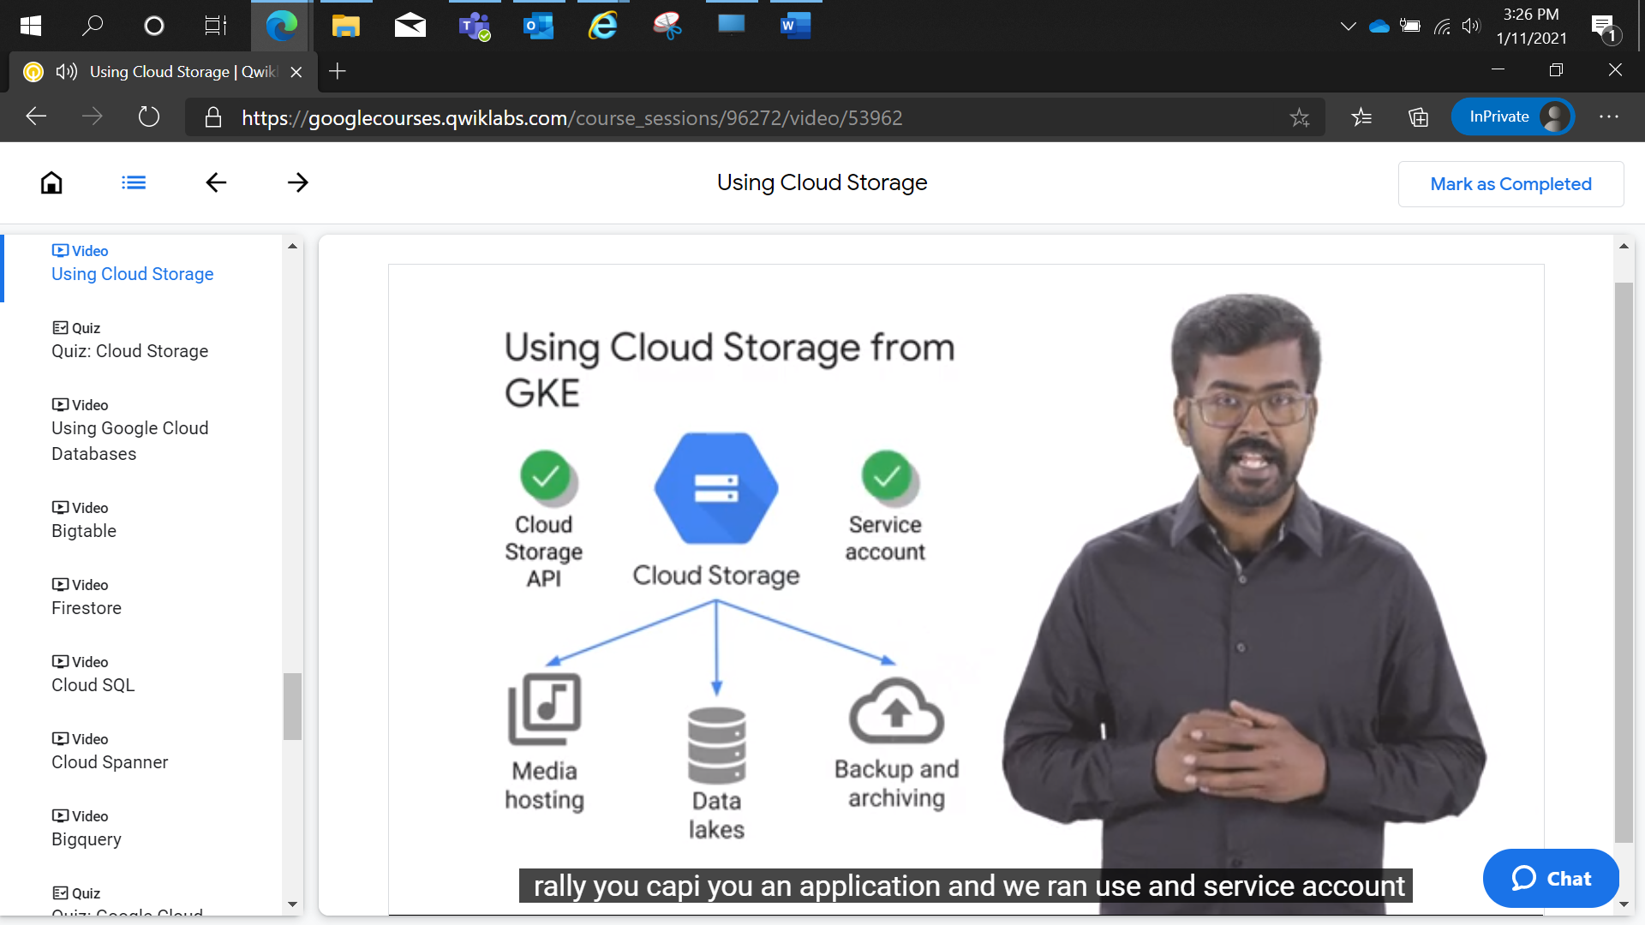

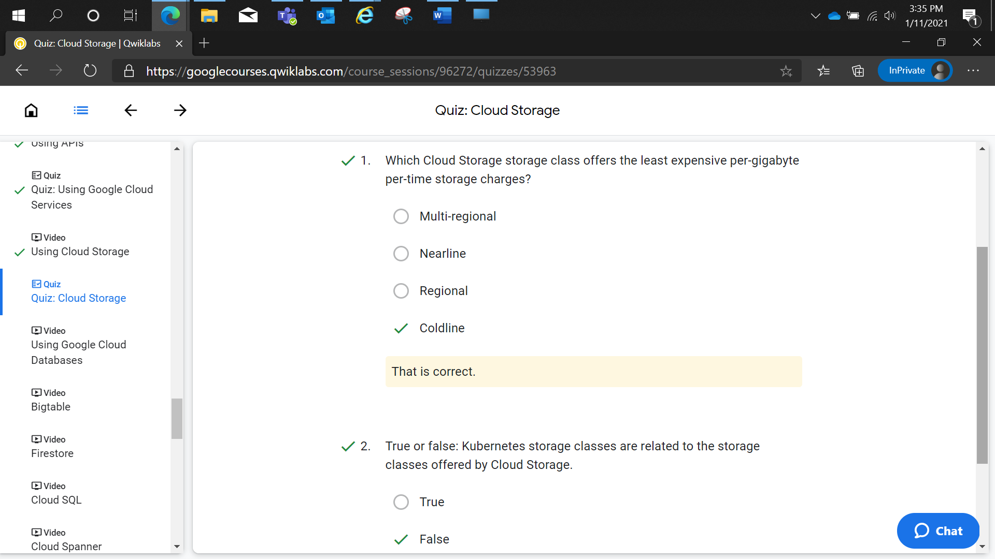

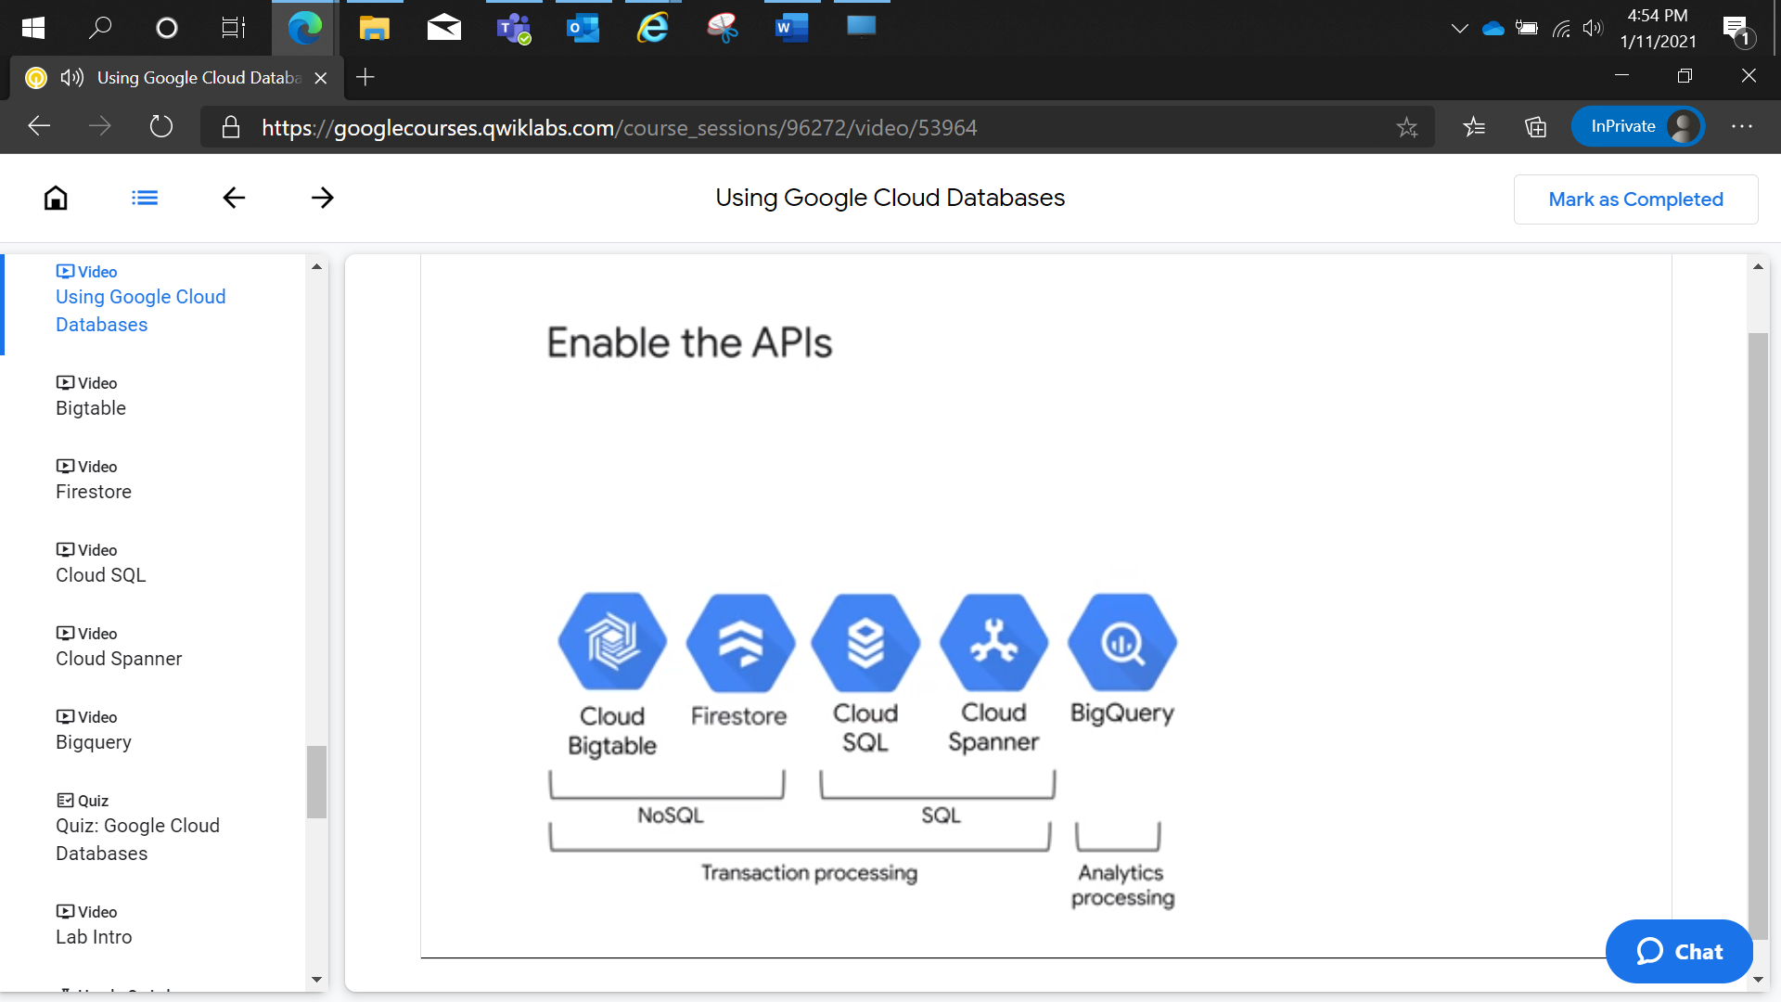

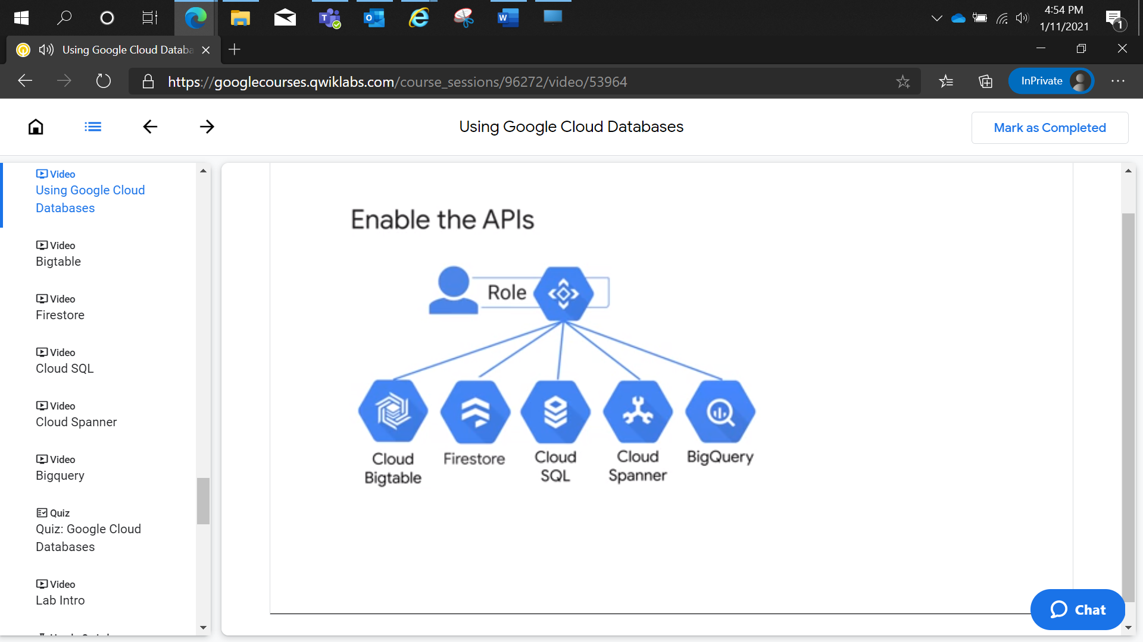

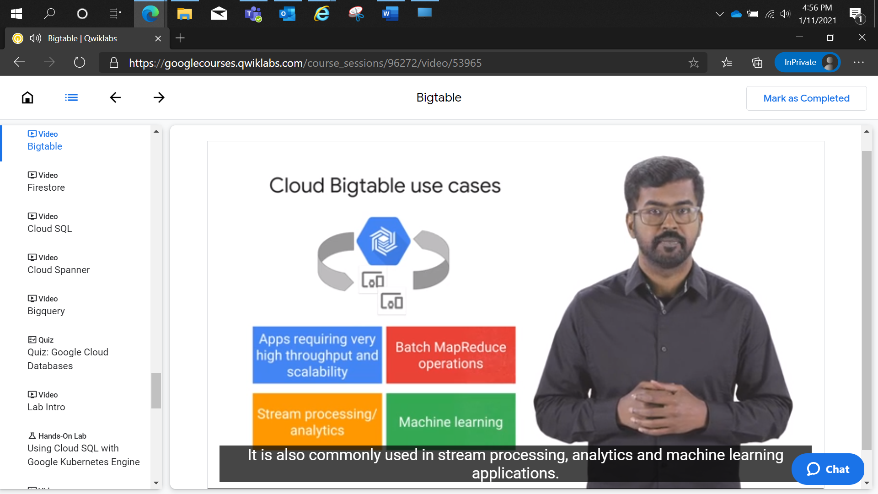

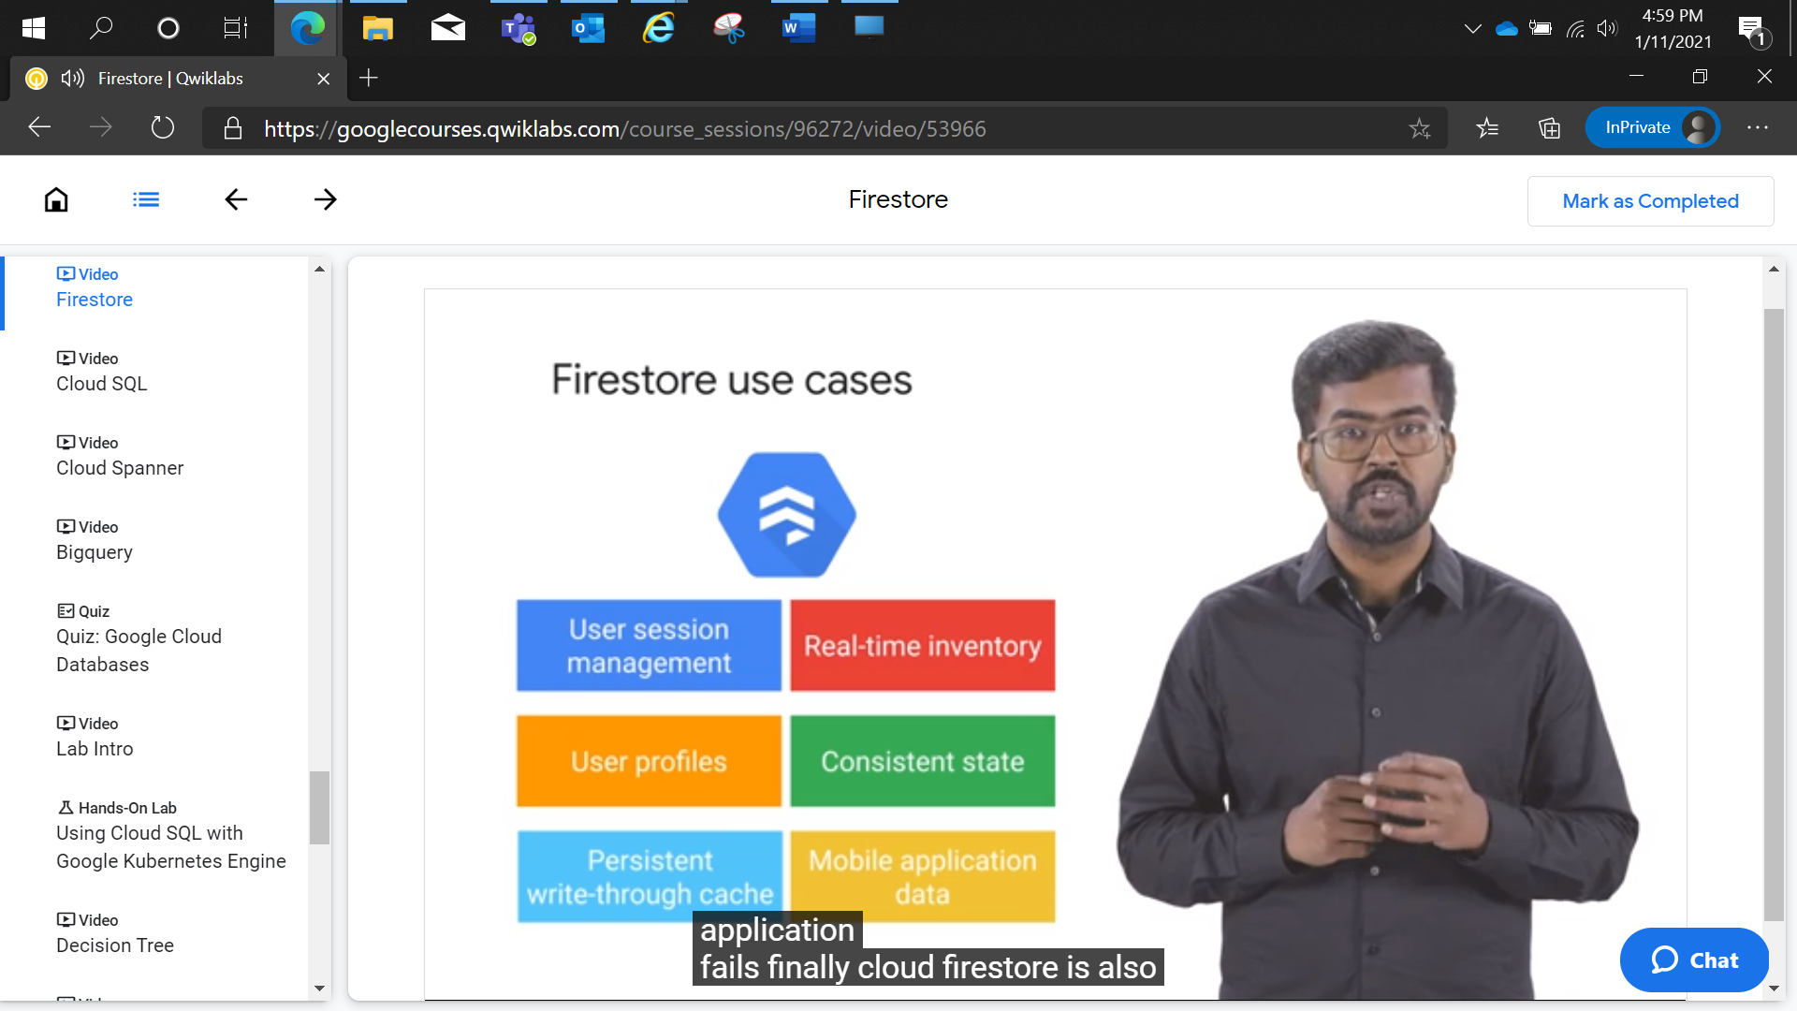

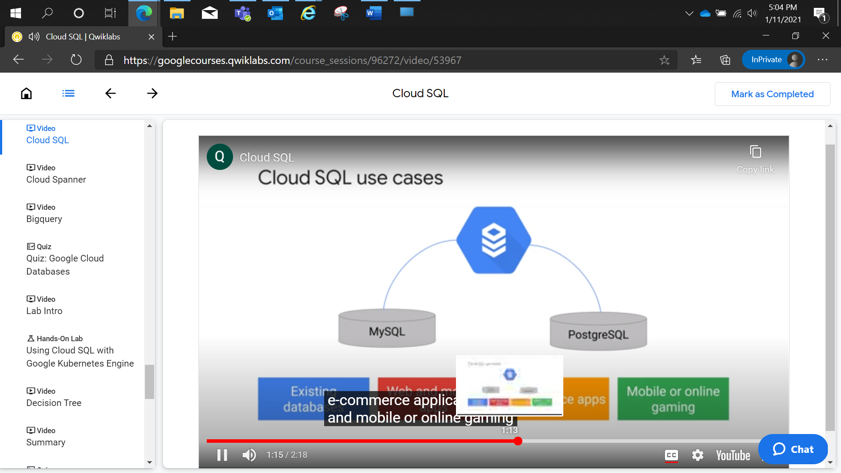

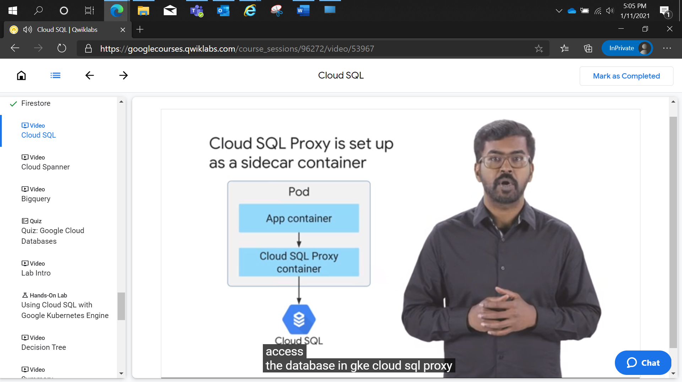

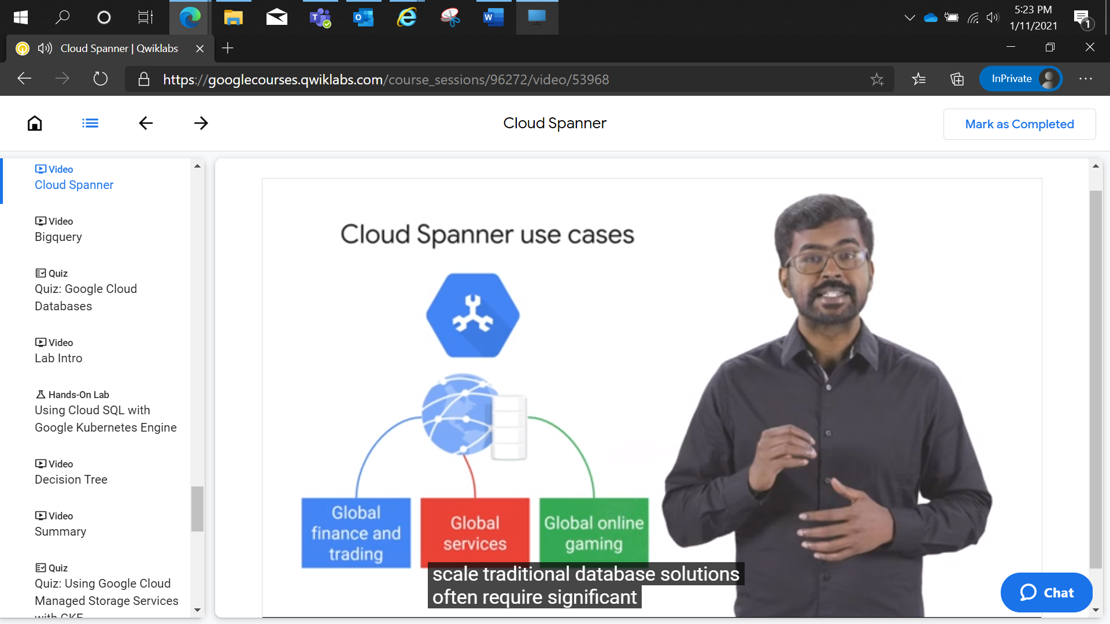

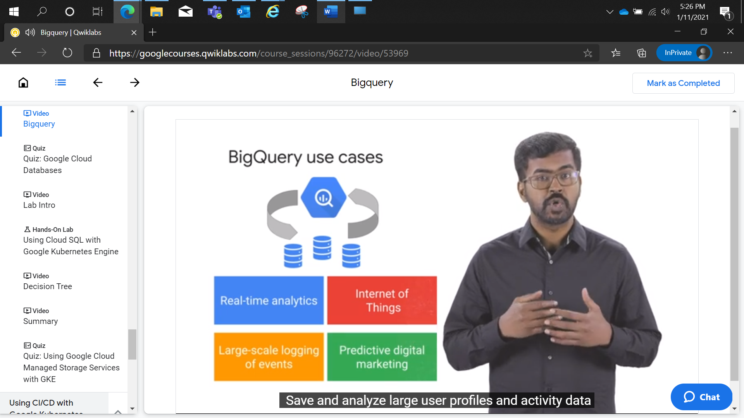

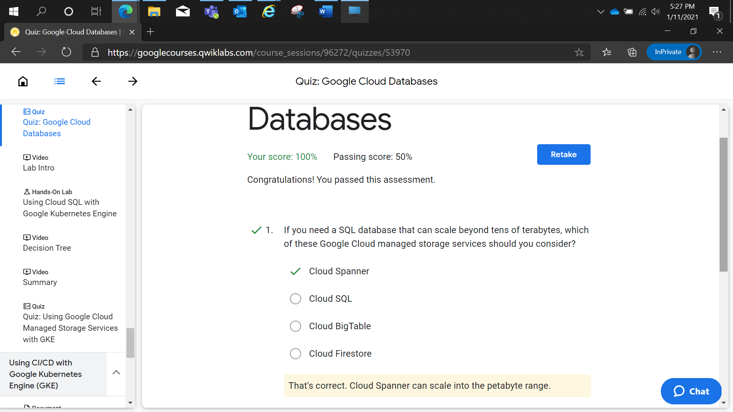

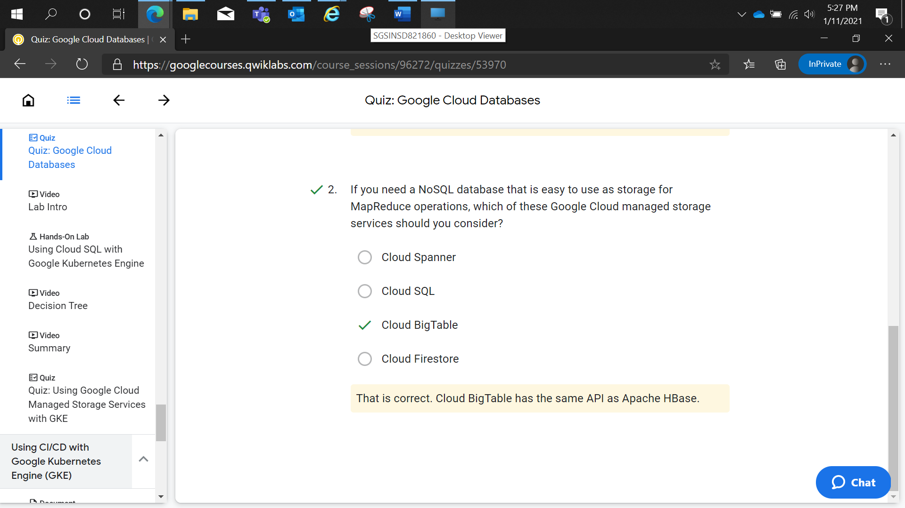

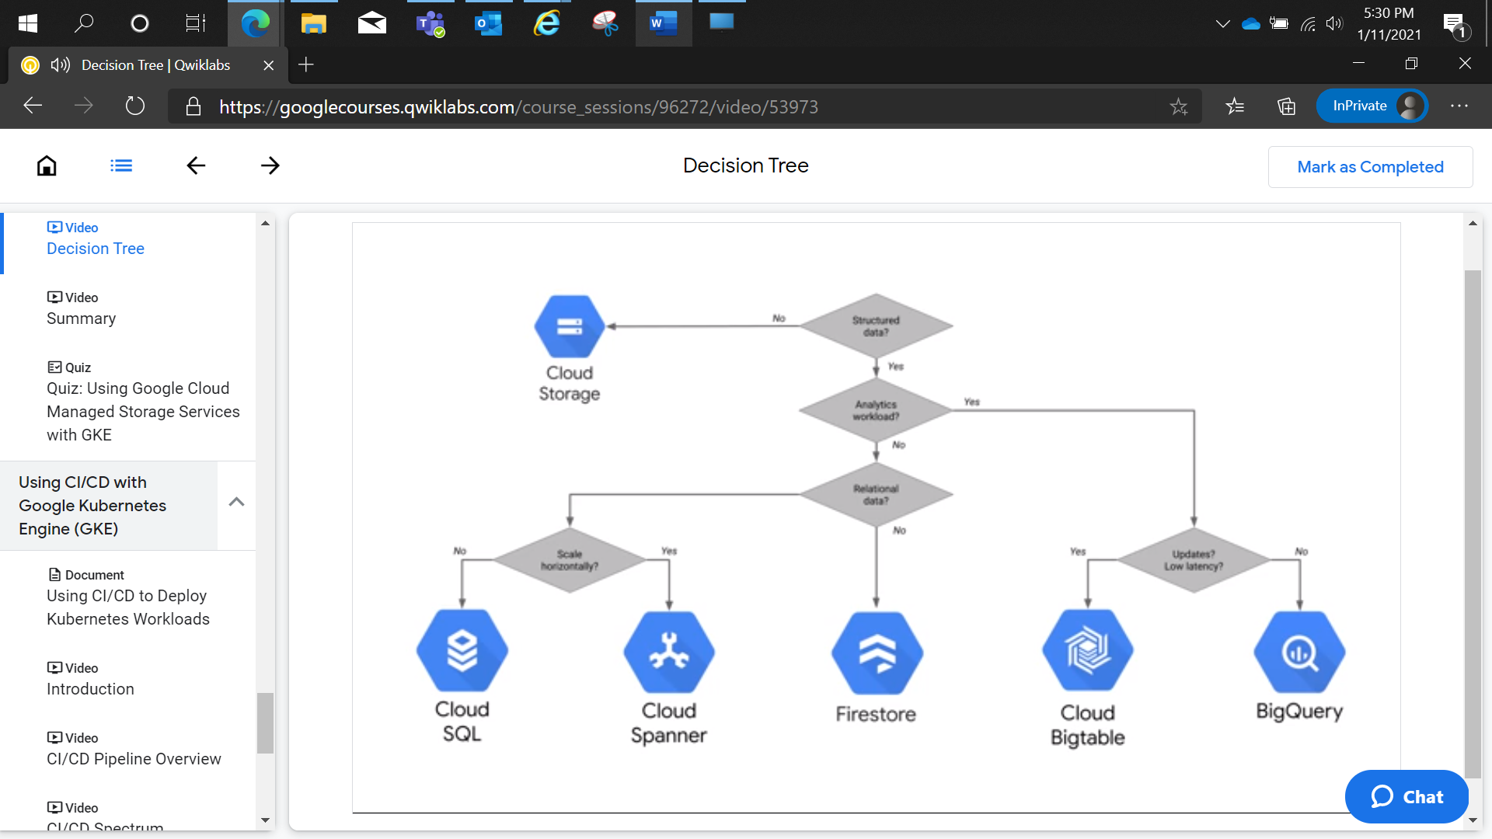

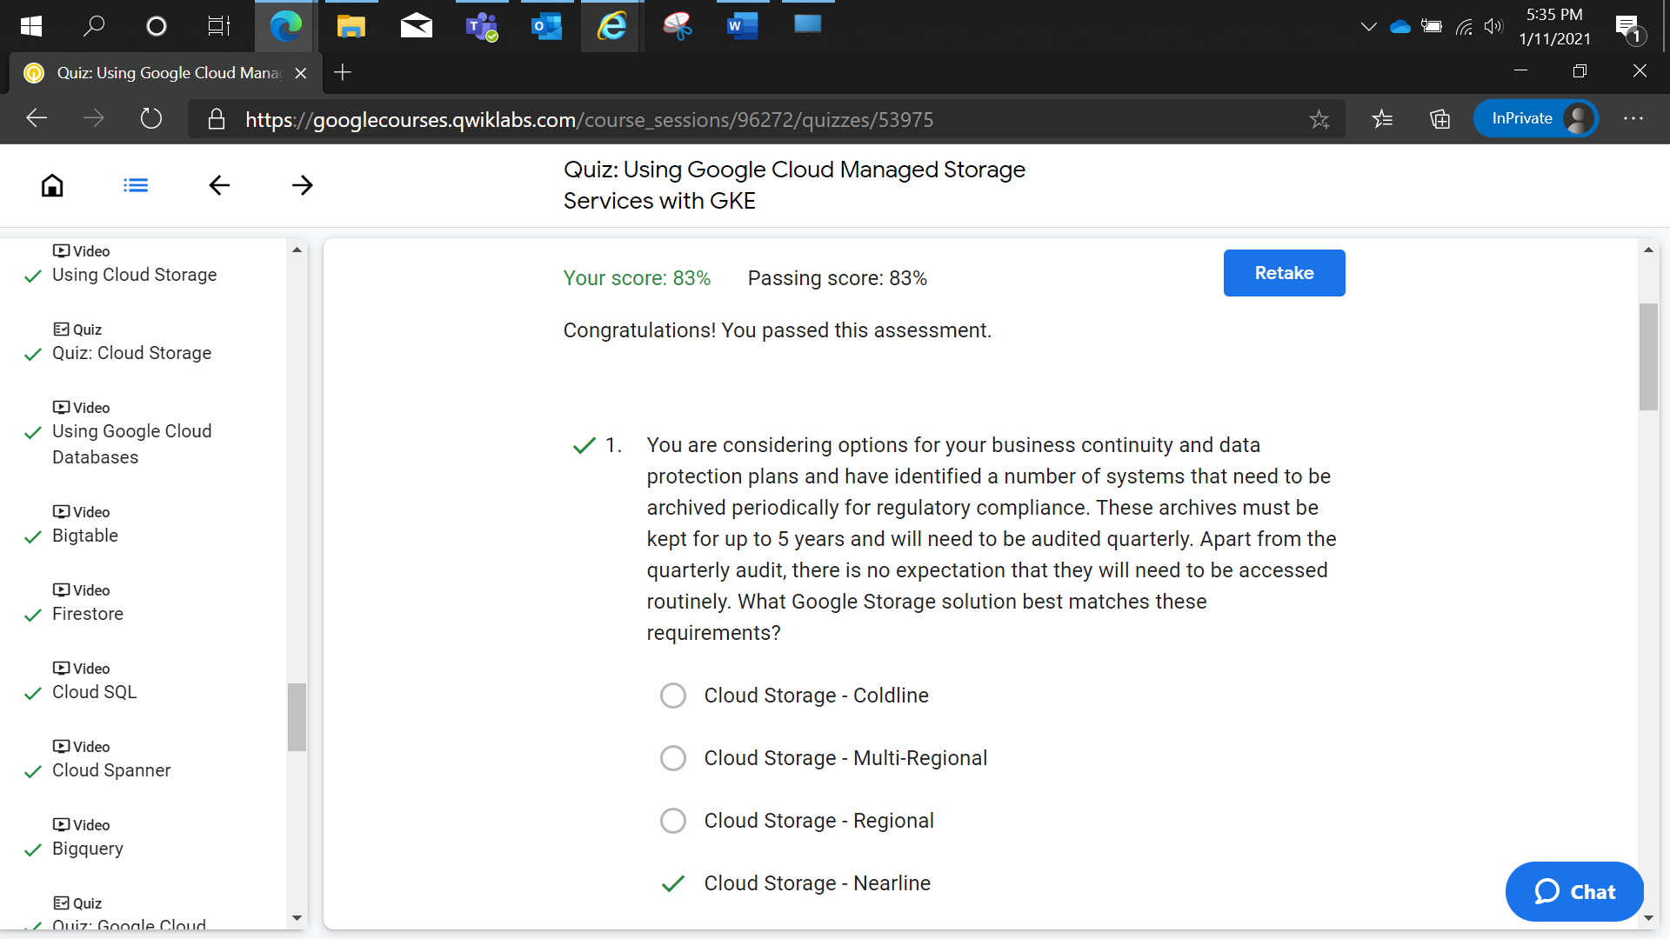

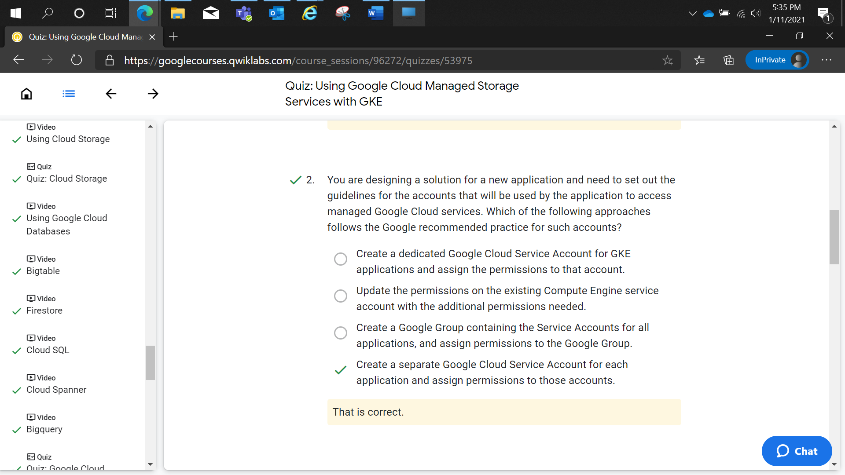

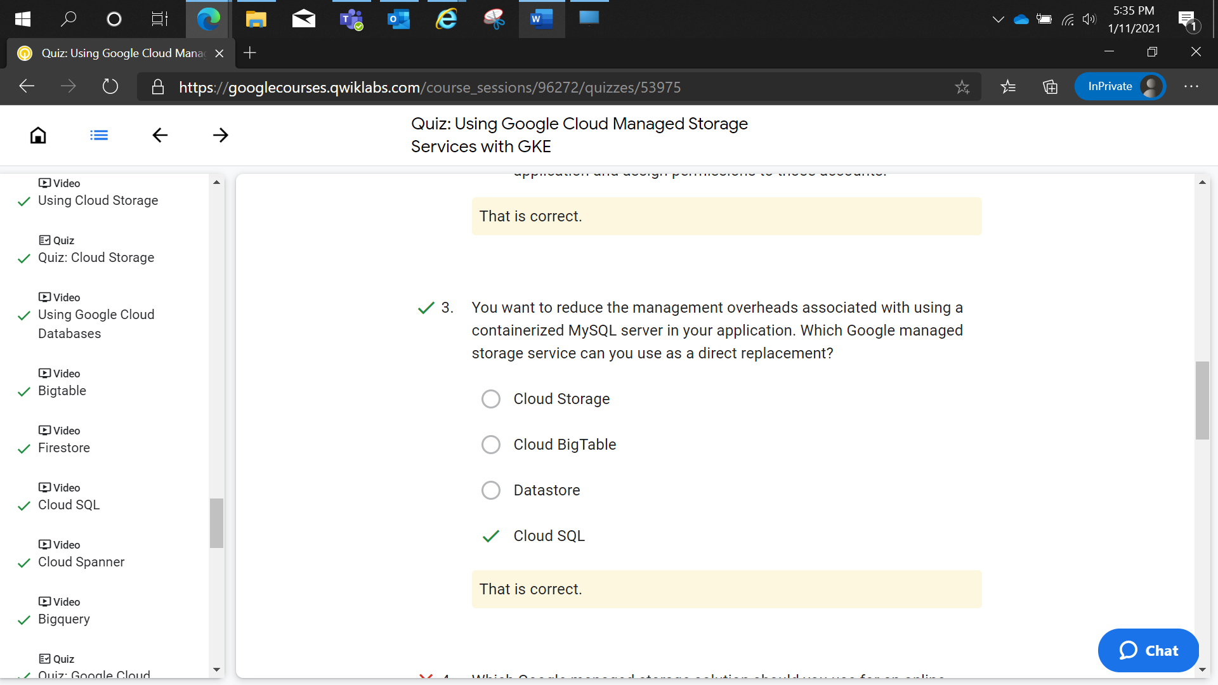

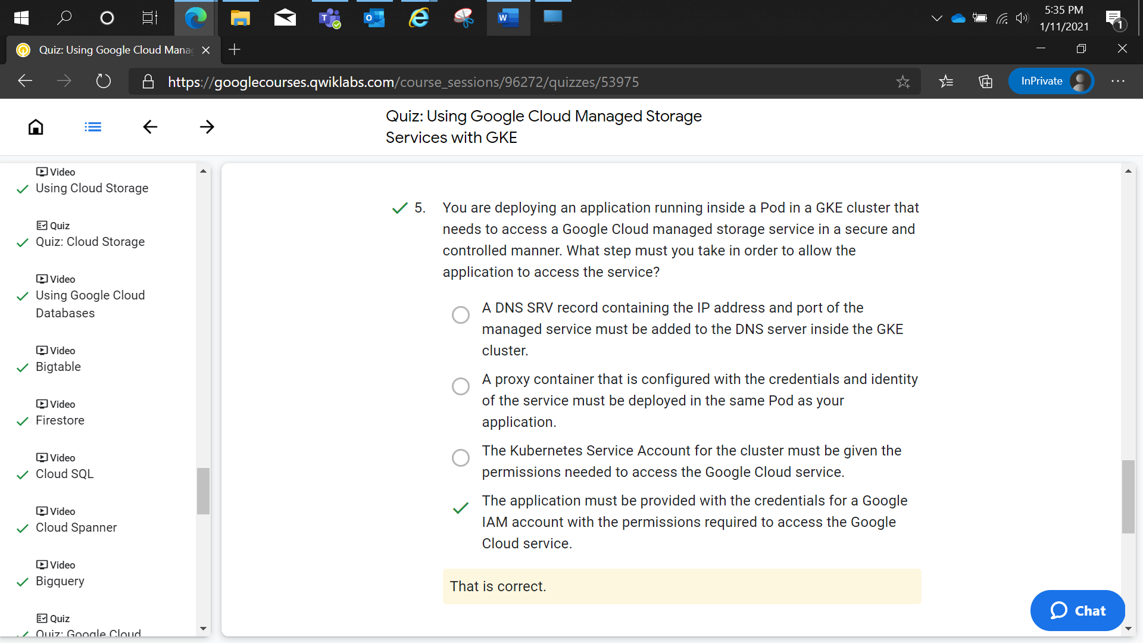

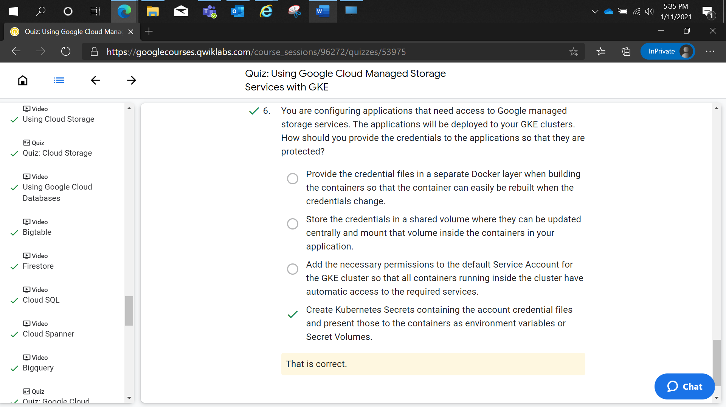

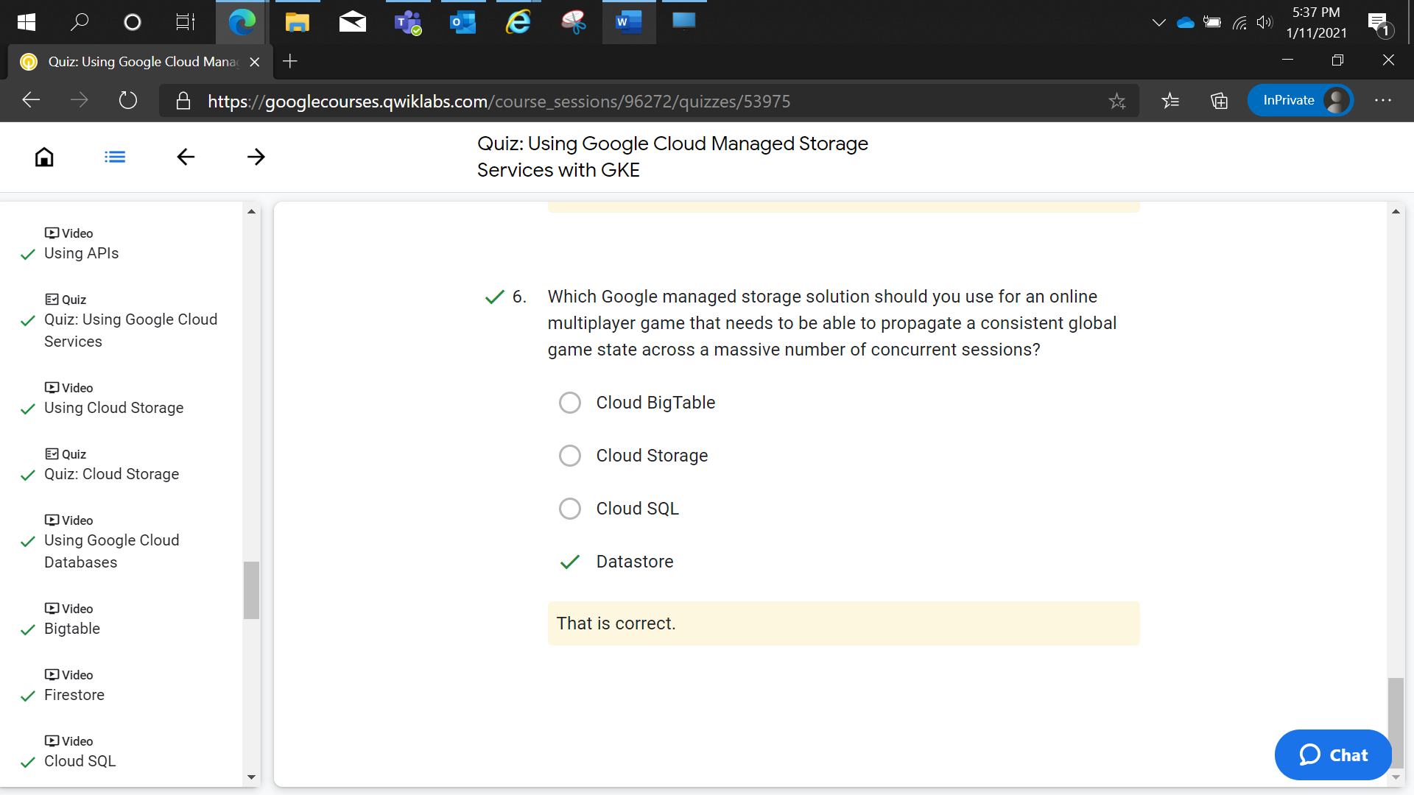

Using Cloud SQL with Google Kubernetes Engine

1 hourFree

Rate Lab

**Overview**

In this lab, you set up a Kubernetes Deployment of WordPress connected to Cloud SQL via the SQL Proxy. The SQL Proxy lets you interact with a Cloud SQL instance as if it were installed locally (localhost:3306), and even though you are on an unsecured port locally, the SQL Proxy makes sure you are secure over the wire to your Cloud SQL Instance.

To complete this lab you'll create several components. First you create a GKE cluster, next you create a Cloud SQL Instance to connect to, and a Service Account to provide permission for your Pods to access the Cloud SQL Instance. Finally you deploy WordPress on your GKE cluster, with the SQL Proxy as a Sidecar, connected to your Cloud SQL Instance.

**Objectives**

In this lab, you learn how to perform the following tasks:

* Create a Cloud SQL instance and database for Wordpress
* Create credentials and Kubernetes Secrets for application authentication
* Configure a Deployment with a Wordpress image to use SQL Proxy
* Install SQL Proxy as a sidecar container and use it to provide SSL access to a CloudSQL instance external to the GKE Cluster

**Task 0. Lab Setup**

**Access Qwiklabs**

For each lab, you get a new GCP project and set of resources for a fixed time at no cost.

1. Make sure you signed into Qwiklabs using an **incognito window**.
2. Note the lab's access time (for example, 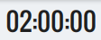 and make sure you can finish in that time block.

There is no pause feature. You can restart if needed, but you have to start at the beginning.

1. When ready, click .
2. Note your lab credentials. You will use them to sign in to Cloud Platform Console. 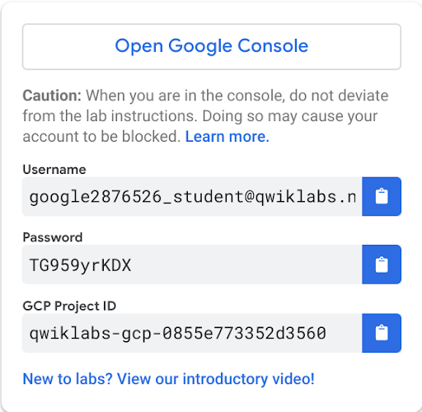
3. Click **Open Google Console**.
4. Click **Use another account** and copy/paste credentials for **this** lab into the prompts.

If you use other credentials, you'll get errors or **incur charges**.

1. Accept the terms and skip the recovery resource page.

Do not click **End Lab** unless you are finished with the lab or want to restart it. This clears your work and removes the project.

After you complete the initial sign-in steps, the project dashboard appears.

Activate Google Cloud Shell

Google Cloud Shell is a virtual machine that is loaded with development tools. It offers a persistent 5GB home directory and runs on the Google Cloud. Google Cloud Shell provides command-line access to your GCP resources.

1. In GCP console, on the top right toolbar, click the Open Cloud Shell button.

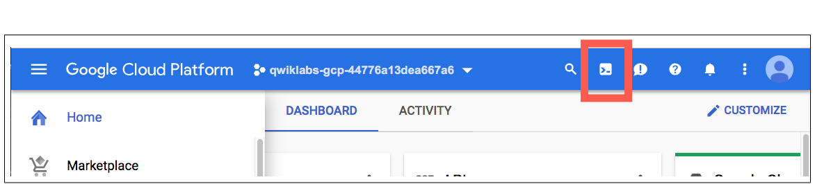

1. Click **Continue**. 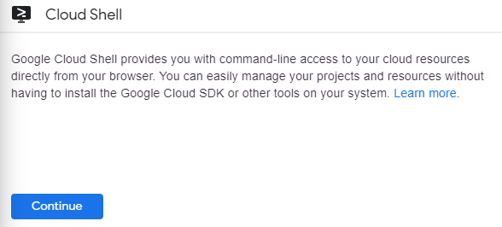

It takes a few moments to provision and connect to the environment. When you are connected, you are already authenticated, and the project is set to your *PROJECT_ID*. For example:

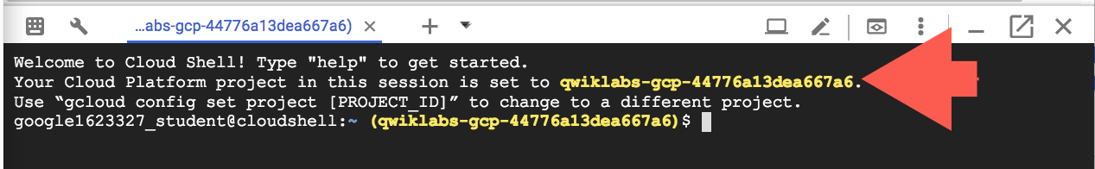

**gcloud** is the command-line tool for Google Cloud Platform. It comes pre-installed on Cloud Shell and supports tab-completion.

You can list the active account name with this command:

gcloud auth list

content_copy

Output:

Credentialed accounts:

- <myaccount>@<mydomain>.com (active)content_copy

Example output:

Credentialed accounts:

- google1623327_student@qwiklabs.netcontent_copy

You can list the project ID with this command:

gcloud config list project

content_copy

Output:

[core]

project = <project_ID>content_copy

Example output:

[core]

project = qwiklabs-gcp-44776a13dea667a6content_copy

Full documentation of **gcloud** is available on [Google Cloud gcloud Overview](https://cloud.google.com/sdk/gcloud).

**Task 1. Connect to the lab GKE cluster**

1. In Cloud Shell, type the following command to set the environment variable for the Google Cloud zone and cluster name.

export my_zone=us-central1-a

export my_cluster=standard-cluster-1

content_copy

1. Configure tab completion for the kubectl command-line tool.

source <(kubectl completion bash)

content_copy

1. Configure access to your cluster for kubectl:

gcloud container clusters get-credentials $my_cluster --zone $my_zone

content_copy

1. In Cloud Shell enter the following command to clone the lab repository to the lab Cloud Shell.

git clone https://github.com/GoogleCloudPlatform/training-data-analyst

content_copy

1. Create a soft link as a shortcut to the working directory.

ln -s ~/training-data-analyst/courses/ak8s/v1.1 ~/ak8s

content_copy

1. Change to the directory that contains the sample files for this lab.

cd ~/ak8s/Cloud_SQL/

content_copy

**Task 2. Enable Cloud SQL APIs**

1. In the Google Cloud Console, on the **Navigation menu** (), click **APIs & Services**.
2. Click **+ Enable APIs and Services**.
3. For **Search for APIs & Services**, type **SQL** and then click the **Cloud SQL** API tile.
4. Click **Enable** to enable Cloud SQL API.

If the API is already enabled, a **Manage** button appears instead, with an **API enabled** message. In that case, no action is required.

1. Repeat the above step to enable **Cloud SQL Admin API**.

**Task 3. Create a Cloud SQL instance**

1. In the Cloud Shell, run the following command to create the instance:

gcloud sql instances create sql-instance --tier=db-n1-standard-2 --region=us-central1

content_copy

1. In the Google Cloud Console, navigate to **SQL**.
2. You should see sql-instance listed , click on the name, and then click on the **Users** menu.

**Note:** You have to wait a few minutes for the Cloud SQL instance to be provisioned.

When you see the existing root user listed you can proceed to the next step.

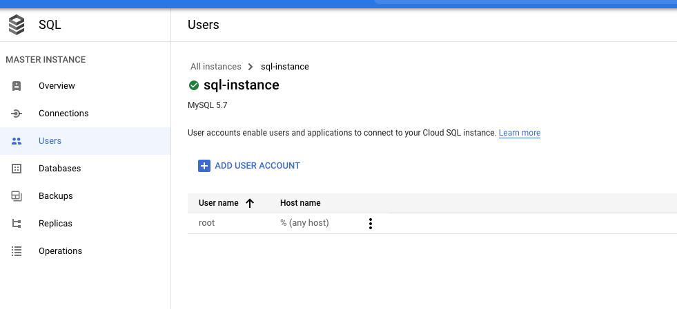

1. Click **ADD USER ACCOUNT** and create an account, using sqluser as the username and sqlpassword as the password.

Leave the **Host name** option set to **Allow any host (%).** and click **ADD**.

1. Go back to **Overview** menu, still in your instance (sql-instance), and copy your Instance connection name.

You will probably need to scroll down a bit to see it.

1. Create an environment variable to hold your Cloud SQL instance name, substituting the placeholder with the name you copied in the previous step.

export SQL_NAME=[Cloud SQL Instance Name]

content_copy

1. Your command should look similar to the following:



1. Connect to your Cloud SQL instance.

gcloud sql connect sql-instance

content_copy

1. When prompted to enter the root password press enter. The root SQL user password is blank by default.

The MySQL [(none)]> prompt appears indicating that you are now connected to the Cloud SQL instance using the MySQL client.

1. Create the database required for Wordpress. This is called wordpress by default.

create database wordpress;

content_copy

1. Select the wordpress database:

use wordpress;

content_copy

1. Select the wordpress database:

show tables;

content_copy

This will report Empty set as you have not created any tables yet.

1. Exit the MySQL client.

exit;

content_copy

Click Check my progress to verify the objective.

Create a Cloud SQL Instance

Check my progress

**Task 4. Prepare a Service Account with permission to access Cloud SQL**

1. To create a Service Account, in the Google Cloud Console navigate to **IAM & admin**> **Service accounts**.
2. Click **+ Create Service Account**.
3. Specify a **Service account name** called sql-access then click **Create**.
4. Click **Select a role.**
5. Search for **Cloud SQL**, select **Cloud SQL Client** and click **Continue**.
6. Click **Done**.
7. Locate the service account sql-access and click on three dots icon in **Actions** column.
8. Click **Create Key**, and make sure **JSON** key type is selected and click **Create**.

This will create a public/private key pair, and download the private key file automatically to your computer. You'll need this JSON file later.

1. Click **Close** to close the notification dialog.
2. Locate the JSON credential file you downloaded and rename it to credentials.json.

Click Check my progress to verify the objective.

Create Service Account

Check my progress

**Task 5. Create Secrets**

You create two Kubernetes Secrets: one to provide the MySQL credentials and one to provide the Google credentials (the service account).

1. To create a Secret for your MySQL credentials, enter the following in the Cloud Shell.

kubectl create secret generic sql-credentials \

--from-literal=username=sqluser\

--from-literal=password=sqlpassword

content_copy

If you used a different username and password when creating the Cloud SQL user accounts substitute those here.

1. In the Cloud Shell, click the **More** icon on the far right of the Cloud Shell menu bar.



1. Select **Upload File** and upload the credentials.json credential file you downloaded in the previous task to the Cloud Shell.
2. In the Cloud Shell move the credential file to the current working directory.

mv ~/credentials.json .

content_copy

Files uploaded to the Cloud Shell are uploaded to the user's home directory. It is easier to work with files in the current working directory with kubectl so moving it makes the next step simpler.

1. Create a Secret for your Google Cloud Service Account credentials using the following command:

kubectl create secret generic google-credentials\

--from-file=key.json=credentials.json

content_copy

Note that the file is uploaded to the Secret using the name key.json. That is the file name that a container will see when this Secret is attached as a Secret Volume.

Click Check my progress to verify the objective.

Create Secrets

Check my progress

**Task 6. Deploy the SQL Proxy agent as a sidecar container**

A sample deployment manifest file called sql-proxy.yaml has been provided for you that deploys a demo Wordpress application container with the SQL Proxy agent as a sidecar container.

In the Wordpress container environment settings the WORDPRESS_DB_HOST is specified using the localhost IP address. The cloudsql-proxy sidecar container is configured to point to the Cloud SQL instance you created in the previous task. The database username and password are passed to the Wordpress container as secret keys, and the JSON credentials file is passed to the container using a Secret volume. A Service is also created to allow you to connect to the Wordpress instance from the internet.

apiVersion: apps/v1

kind: Deployment

metadata:

name: wordpress

labels:

app: wordpress

spec:

selector:

matchLabels:

app: wordpress

template:

metadata:

labels:

app: wordpress

spec:

containers:

- name: web

image: gcr.io/cloud-marketplace/google/wordpress

ports:

- containerPort: 80

env:

- name: WORDPRESS_DB_HOST

value: 127.0.0.1:3306

# These secrets are required to start the pod.

# [START cloudsql_secrets]

- name: WORDPRESS_DB_USER

valueFrom:

secretKeyRef:

name: sql-credentials

key: username

- name: WORDPRESS_DB_PASSWORD

valueFrom:

secretKeyRef:

name: sql-credentials

key: password

# [END cloudsql_secrets]

# Change <INSTANCE_CONNECTION_NAME> here to include your Google Cloud

# project, the region of your Cloud SQL instance and the name

# of your Cloud SQL instance. The format is

# $PROJECT:$REGION:$INSTANCE

# [START proxy_container]

- name: cloudsql-proxy

image: gcr.io/cloudsql-docker/gce-proxy:1.11

command: ["/cloud_sql_proxy",

"-instances=<INSTANCE_CONNECTION_NAME>=tcp:3306",

"-credential_file=/secrets/cloudsql/key.json"]

# [START cloudsql_security_context]

securityContext:

runAsUser: 2 # non-root user

allowPrivilegeEscalation: false

# [END cloudsql_security_context]

volumeMounts:

- name: cloudsql-instance-credentials

mountPath: /secrets/cloudsql

readOnly: true

# [END proxy_container]

# [START volumes]

volumes:

- name: cloudsql-instance-credentials

secret:

secretName: google-credentials

# [END volumes]

---

apiVersion: "v1"

kind: "Service"

metadata:

name: "wordpress-service"

namespace: "default"

labels:

app: "wordpress"

spec:

ports:

- protocol: "TCP"

port: 80

selector:

app: "wordpress"

type: "LoadBalancer"

loadBalancerIP: ""

content_copy

The important sections to note in this manifest are:

* In the Wordpress env section the variable WORDPRESS_DB_HOST is set to 127.0.0.1:3306. This will connect to a container in the same Pod listening on port 3306. This is the port that the SQL-Proxy listens on by default.
* In the Wordpress env section the variables WORDPRESS_DB_USER and WORDPRESS_DB_PASSWORD are set using values stored in the sql-credential Secret you created in the last task.
* In the cloudsql-proxy container section the command switch that defines the SQL Connection name, "-instances=<INSTANCE_CONNECTION_NAME>=tcp:3306", contains a placeholder variable that is not configured using a ConfigMap or Secret and so must be updated directly in this example manifest to point to your Cloud SQL instance.
* In the cloudsql-proxy container section the JSON credential file is mounted using the Secret volume in the directory /secrets/cloudsql/ . The command switch "-credential_file=/secrets/cloudsql/key.json" points to the filename in that directory that you specified when creating the google-credentials Secret.
* The Service section at the end creates an external LoadBalancer called "wordpress-service" that allows the application to be accessed from external internet addresses.

1. Use sed to update the placeholder variable for the SQL Connection name to the instance name of your Cloud SQL instance.

sed -i 's/<INSTANCE_CONNECTION_NAME>/'"${SQL_NAME}"'/g'\

sql-proxy.yaml

content_copy

1. Deploy the application.

kubectl apply -f sql-proxy.yaml

content_copy

1. Query the status of the Deployment:

kubectl get deployment wordpress

content_copy

**Note:** You need to repeat this command until you see that an instance is available.

NAME READY UP-TO-DATE AVAILABLE AGE

wordpress 1/1 1 1 45scontent_copy

1. List the services in your GKE cluster.

kubectl get services

content_copy

The external LoadBalancer ip-address for the wordpress-service is the address you use to connect to your Wordpress blog. Repeat the command until you get an external address as shown here.

NAME TYPE CLUSTER-IP EXTERNAL-IP PORT(S)

kubernetes ClusterIP 10.12.0.1 <none> 443/TCP

wordpress-service LoadBalancer 10.12.3.17 35.238.218.6 80:31095/TCPcontent_copy

Click Check my progress to verify the objective.

Deploy the SQL Proxy agent as a sidecar container

Check my progress

**Task 7. Connect to your Wordpress instance**

1. Open a new browser tab and connect to your Wordpress site using the external LoadBalancer ip-address. This will start the initial Wordpress installation wizard.
2. Select **English (United States)** and click **Continue**.
3. Enter a sample name for the **Site Title**.
4. Enter a **Username** and **Password** to administer the site.
5. Enter an email address.

None of these values are particularly important, you will not need to use them.

1. Click **Install Wordpress**.

After a few seconds you will see the **Success!** Notification. You can log in if you wish to explore the Wordpress admin interface but it is not required for the lab.

The initialization process has created new database tables and data in the wordpress database on your Cloud SQL instance. You will now validate that these new database tables have been created using the SQL proxy container.

1. Switch back to the Cloud Shell and connect to your Cloud SQL instance.

gcloud sql connect sql-instance

content_copy

1. When prompted to enter the root password press enter. The root SQL user password is blank by default.

The MySQL [(none)]> prompt appears indicating that you are now connected to the Cloud SQL instance using the MySQL client.

1. Select the wordpress database:

use wordpress;

content_copy

1. Select the wordpress database:

show tables;

content_copy

This will now show a number of new database tables that were created when Wordpress was initialized demonstrating that the sidecar SQL Proxy container was configured correctly.

MySQL [wordpress]> show tables;

+-----------------------+

| Tables_in_wordpress |

+-----------------------+

| wp_commentmeta |

| wp_comments |

| wp_links |

| wp_options |

| wp_postmeta |

| wp_posts |

| wp_term_relationships |

| wp_term_taxonomy |

| wp_termmeta |

| wp_terms |

| wp_usermeta |

| wp_users |

+-----------------------+

12 rows in set (0.19 sec)content_copy

1. List all of the Wordpress user table entries:

select * from wp_users;

content_copy

This will list the database record for the Wordpress admin account showing the email you chose when initializing Wordpress.

1. Exit the MySQL client.

exit;